

Semester One Examination, 2021

Question/Answer booklet

MATHEMATICS SPECIALIST
UNIT 3

Section One:

Calculator-free

Your Name

Your Teacher’s Name

Time allowed for this section
Reading time before commencing work: five minutes
Working time: fifty minutes

Materials required/recommended for this section
To be provided by the supervisor
This Question/Answer booklet
Formula sheet

To be provided by the candidate
Standard items: pens (blue/black preferred), pencils (including coloured), sharpener, correction fluid/tape, eraser, ruler, highlighters

Special items: nil

Important note to candidates
No other items may be taken into the examination room. It is your responsibility to ensure that you do not have any unauthorised material. If you have any unauthorised material with you, hand it to the supervisor before reading any further.
Question | Mark | Max | Question | Mark | Max
1 |  |  | 5
2 |  |  | 6
3 |  |  | 7
4 |  |  | 8

Structure of this paper

Section | Number of questions available | Number of questions to be answered | Working time (minutes) | Marks available | Percentage of examination
Section One:  Calculator-free | 8 | 8 | 50 | 50 | 34
Section Two:  Calculator-assumed | 14 | 14 | 100 | 96 | 66
 |  |  |  | Total | 100

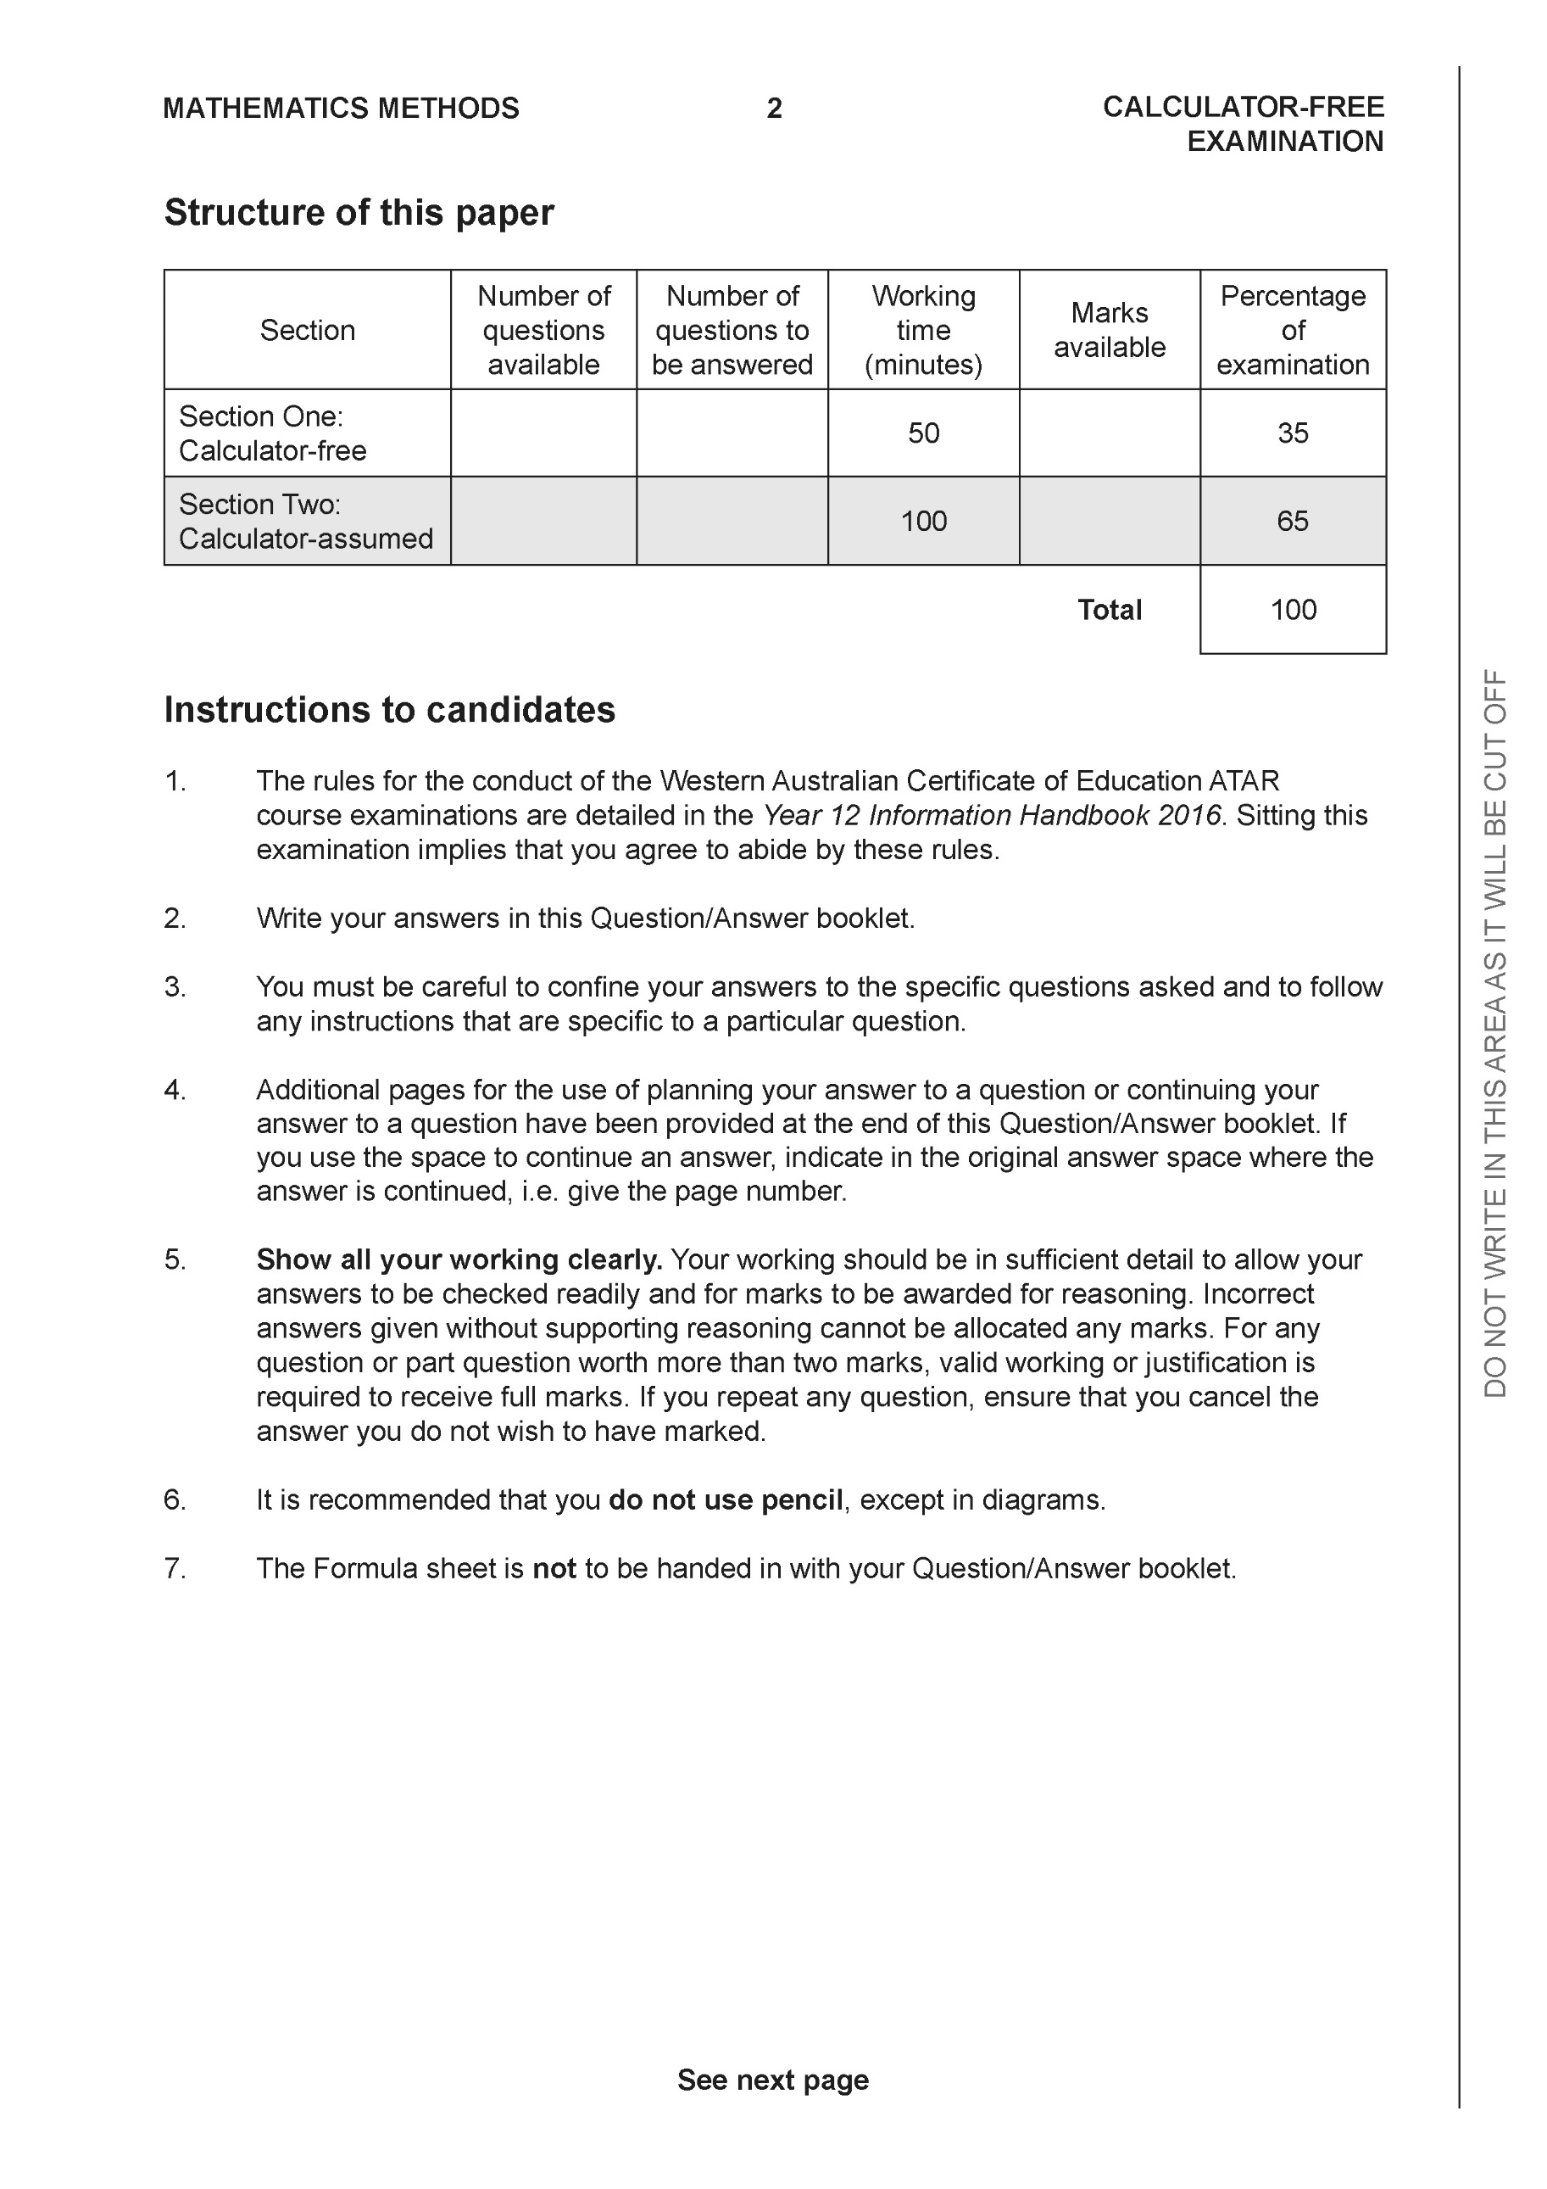

Section One: Calculator-free (50 Marks)

This section has eight (8) questions. Answer all questions. Write your answers in the spaces provided.

Spare pages are included at the end of this booklet. They can be used for planning your responses and/or as additional space if required to continue an answer.
● Planning: If you use the spare pages for planning, indicate this clearly at the top of the page.
● Continuing an answer: If you need to use the space to continue an answer, indicate in the original answer space where the answer is continued, i.e. give the page number. Fill in the number of the question that you are continuing to answer at the top of the page.

Working time: 50 minutes.

Question 1 (6 marks)

Consider the plane which contains point A

(a) Write a vector equation for this plane. (3 marks)

Solution
Specific behaviours
identifies a normal vector
shows dot product to determine scalar constant
uses correct format for vector equation

Consider the line
(b) Determine the coordinates of where the line above meets the plane. (3 marks)

Solution
Specific behaviours
sets up dot product equation
solves for parameter
subs parameter back into equation (no need to simplify)

Question 2 (6 marks)

Sketch the graph where . Clearly show the major features of the graph.

Solution
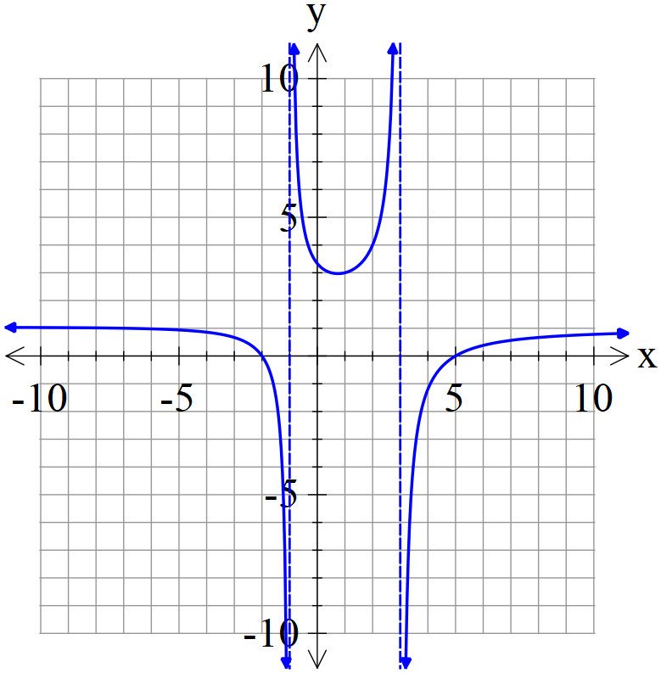

Specific behaviours
shows both vertical asymptotes
shows both x intercepts(exact)
shows approx. y intercept
shows horizontal asymptote
two of the three parts have correct shape
all parts have correct shape

Question 3 (6 marks)

Consider the plane that contains the following three points . Using vector methods, determine the distance of point from the plane . Show all working and reasoning.

Solution
Specific behaviours
determines two vectors in plane
uses cross product to find a normal
Determines a vector from D to any point on plane OR uses a line through D parallel to normal
uses dot product or finds intersection of line & plane
uses unit normal or solves for parameter of line
determines exact distance(accept irrational denominator)

Question 4 (5 marks)

Consider the function as graphed below.
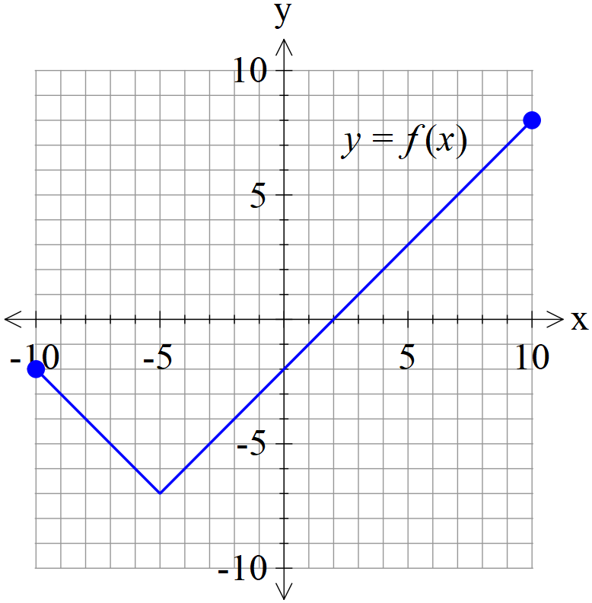
- Graph on the axes below. (2 marks)

Solution
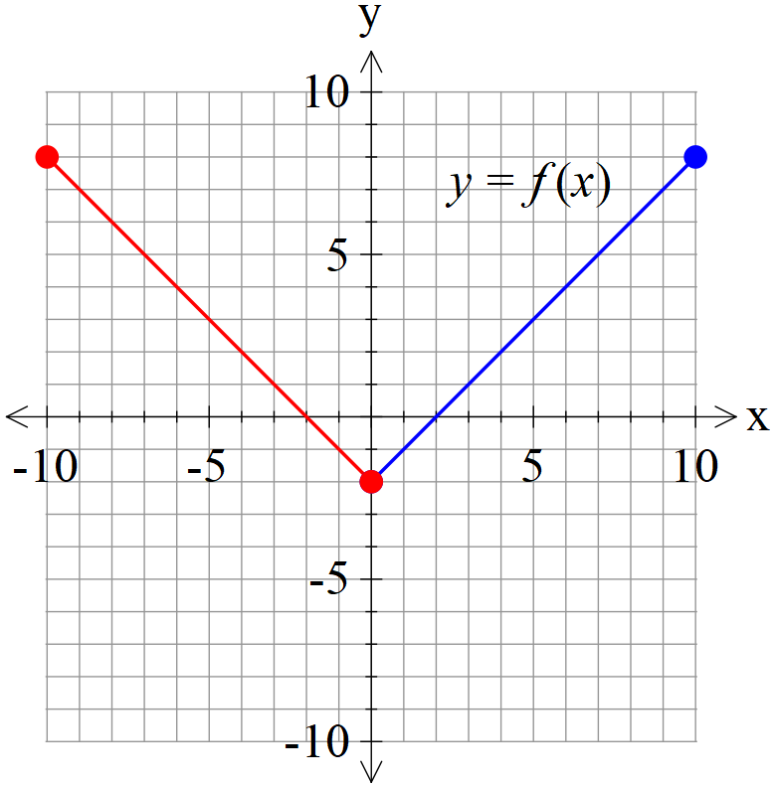

Specific behaviours
reflects one side
correct graph

- Graph on the axes below. (3 marks)

Solution
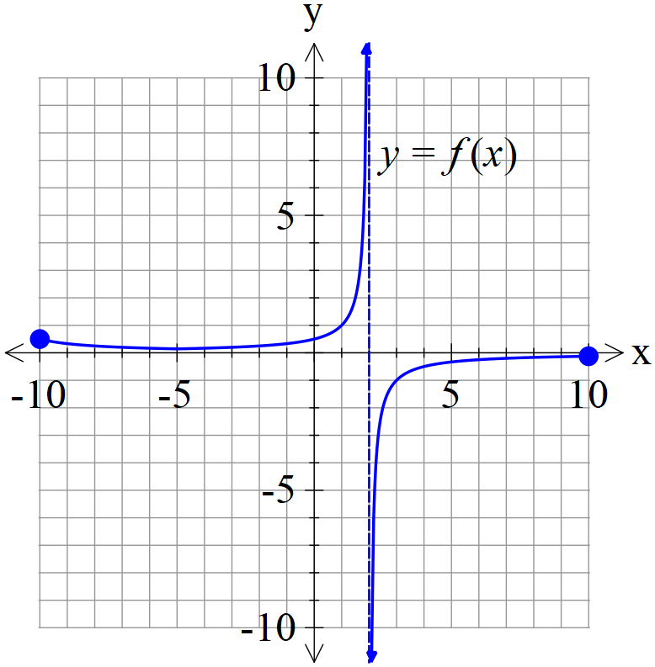

Specific behaviours
shows asymptote
approx. y intercept and min turning pt at x=-5 ( do not accept max)
correct shape on both sides of asymptote

Question 5 (7 marks)

Consider the function with domain

(a) Determine and its domain. (4 marks)

Solution
Specific behaviours
swaps x & y OR solves for x as subject
uses a quadratic formula expression OR completes the square
uses minus and states domain of inverse (no need to simplify)
states rule for inverse

(b) Consider with and real constants. Given that has an inverse which intersects graphically with at one point only, determine a possible exact solution for in terms of and an equation that must satisfy.
(3 marks)

Solution
Specific behaviours
equates function to x
uses quadratic formula to give one answer only
uses discriminant equaling zero

Question 6 (7 marks)

Consider the following system of linear equations.

- Solve for . (3 marks)

Solution
Specific behaviours
eliminates one variable for two equations
eliminates two variables for one equation
solves for all three variables

Q6 cont-

- If we modify the equations to the following with being constants, solve for the following values of such that there are:
- no solutions
- infinite solutions (Give a geometrical interpretation of this situation) (4 marks)

Solution
No solns p=-7 and
Infinite p=-7 and
Line of common points that lie on all 3 planes
Specific behaviours
eliminates two variables
states all values for no solns
states values for infinite solns
with geometric explanation

Question 7 (10 marks)

- Solve for all solutions to the following in the form with .
(4 marks)

Solution
Specific behaviours
determines argument of right hand side (third quadrant)
uses De Moivre’s Theorem with arguments in increments of
six roots with correct modulus
six roots, all with correct principal arguments

- Plot the above roots on the diagram below, labelling the axes. (3 marks)

Solution
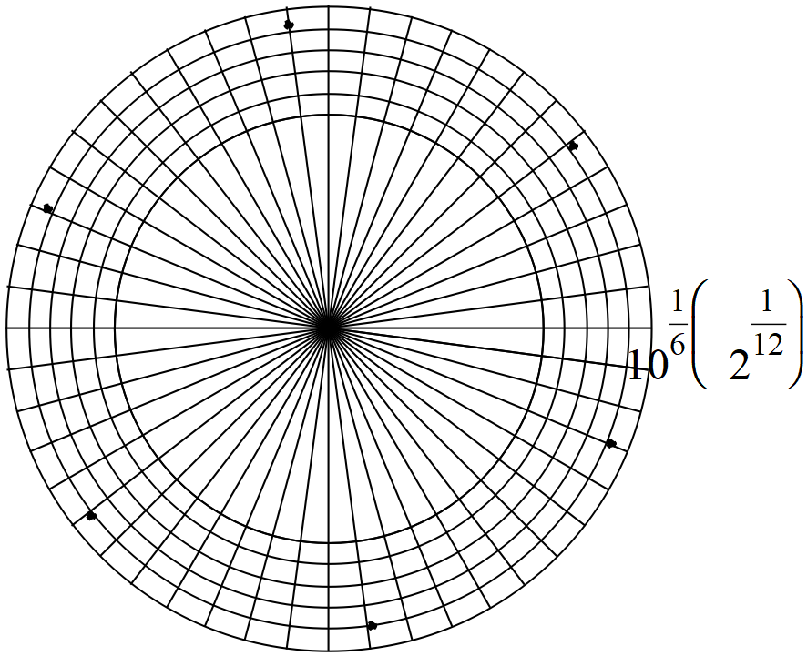

Specific behaviours
one point at correct position
scale indicated
six points equally spaced

- If these points are joined, forming a polygon, determine the exact area of this polygon.
(3 marks)

Solution
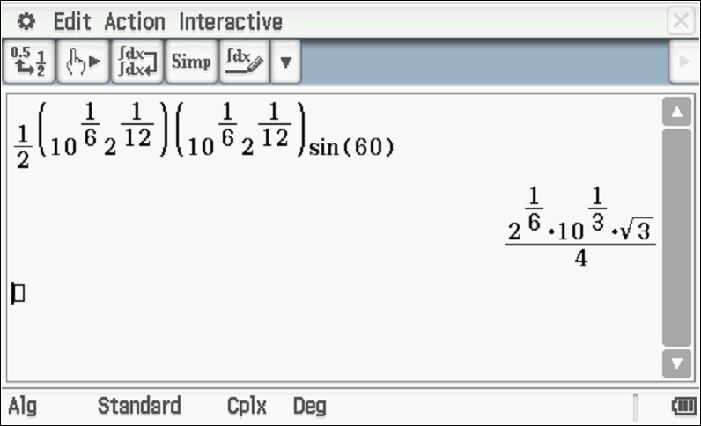
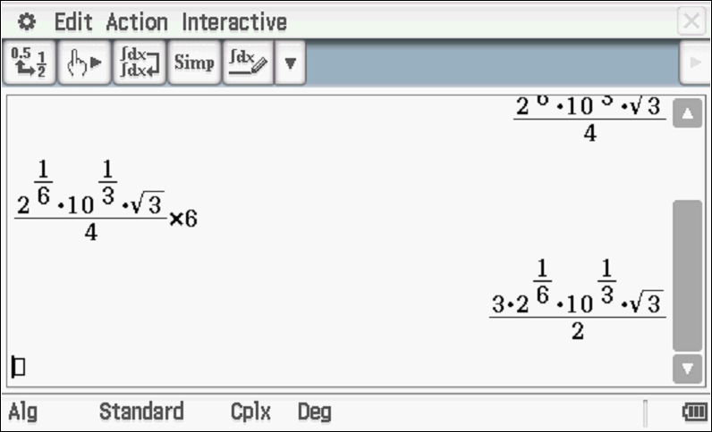

Specific behaviours
uses equilateral triangles with side length equaled to modulus of roots
determines area of one triangle
states total area as an exact expression. (no need to simplify)

Question 8 (3 marks)

Sketch the locus of points that satisfy on the complex plane below and explain your reasoning.

Solution
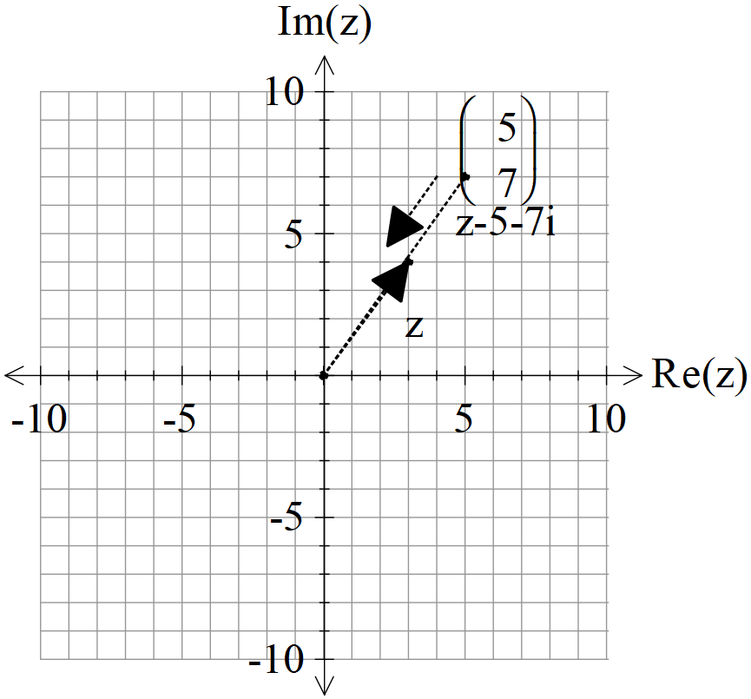

Specific behaviours
uses a line segment
correct endpoints
indicates the two arguments on diagram showing a difference of pi radians

Additional working space
Question number:

Additional working space
Question number:

Additional working space
Question number:

Acknowledgements

